As a Volunteer
Volunteers are needed to help carry out work in Fundraising, Programming, Host Families, Publicity, and Speakers Bureau.
Detach and return this section if interested in participating in the Ulster Project.
I am interested in (please check all that apply):
_____More Information/contact me
_____Becoming a Host Family
_____Becoming a Volunteer
_____Making a Monetary Donation
Name: ____________________________
Address ___________________________
Phone: _____________________
Send to: Alliance Area Ulster Project, PO Box 3224, Alliance, Ohio 44601

Visit our Web Site-www.aaupusa.com
National Web Site – www.ulsterproject.org
Phone 330-821-8225 – Karen Andrews
330-221-3585 – Shirley Ryan
For more information

Facts about the Project
- The Ulster Project is an ecumenical peace movement endorsed by Protestant and Catholic leaders and religious leaders in the United States and Ireland.
- It is not a political organization and it espouses neither a political nor social agenda.
- It is entirely non-sectarian. It does not condone or permit proselytizing of project participants by any group or individual.
- It is not an exchange program. Although it is similar in some respects to cultural and educational exchange programs, the goal of the project is to introduce and promote peace, tolerance, understanding and friendship among teens that are the future.
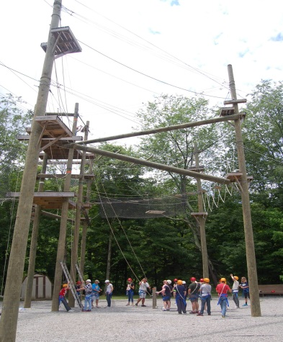
Teens at Elkhorn Valley- Co-operative Learning Experience

The

Alliance

Area

Ulster

Project
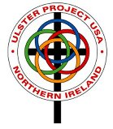
An ecumenical peace project to promote tolerance, understanding and friendship between Protestant and Catholic youth – the future leaders of Northern Ireland
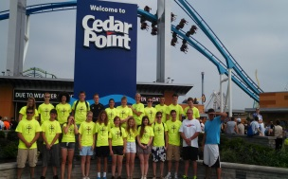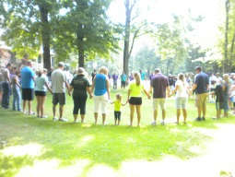

Creating Unity Amidst Diversity

The history of the problem
Ireland has been called a country that has been at war with itself for over 800 years. There is a history that divides the people, and that history has also entrapped them. The reasons are rooted in the 17th century with the consolidation of English authority over Ireland by Protestant English Kings. As Protestant English and Scottish settlers continued to displace Catholic Irish from their lands, religious differences became inextricable enmeshed with political and economic friction.
When the independent Republic of Ireland was formed in 1921, the British retained control over the Northeast corner of Ireland (historically part of the province of Ulster) with its overwhelmingly Protestant majority. A civil rights movement in the late 1960’s, aimed at ending the economic and political discrimination, and escalated into violence and a resurgence of the old animosities. Since 1969 more than 2500 police, soldiers and civilians have died as a result of what the Northern Irish call “the troubles”.
A PLAN FOR PEACE
In 1974, members of both the Protestant and Catholic clergy began an effort to bridge the gap between the fractions of Northern Ireland by bringing young people from both sides of the conflict together on neutral ground in the United States. Fr. Kerry Waterstone, Anglican priest from The Republic of Ireland is the original coordinator of the Ulster Project.

Signs of Hope
When the Ulster Project began, critics claimed that it was naïve to believe that such a simple plan could ever be effective. Even the organizers of the project conceded that it would take decades, perhaps generations, before the effects of project would be felt. But in the entire history of the project, of the more than 8,000 teens who have participated in the project not one of them has succumbed to pressure to join paramilitary or extremist organizations in Northern Ireland.
Now, over 33 years since the first Ulster Project began in the United States, there is hope for sustained peace in Northern Ireland. Recent events in Northern Ireland such as shared government positions and integrated schools hold great promise. However, there is still a long way to go and by maintaining a bridge of peace through the youth there is great potential for the future.

ulster project - alliance
In 1987, Alliance became an Ulster Project host city, joining already existing programs which has grown to 15 projects within the United States. The project hosts an equal number of N. Irish Protestant and Catholic teens between the ages of 14 – 16 for four weeks during the summer. It involves volunteers and teens from many religious denominations in the Alliance area. The N. Irish teens come from Belfast, N. Ireland and the surrounding communities.
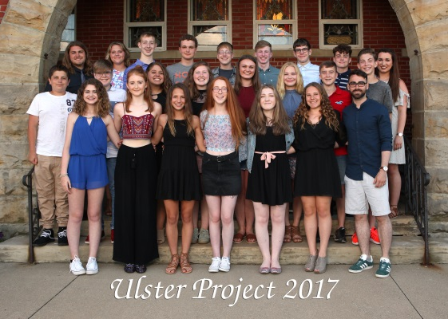
“I think that the project is the best idea ever as it brings people of every religion together without any comments. I wish it could always be like that and the Ulster project is a good place as any to start.” –2018 N. Irish Teen

how you can help
As a Host Family
There are few opportunities when an individual or family can be a Partner in Peace. Becoming a host family is one such time. Host teens are usually between the ages of 14-16. Northern Irish and American teens are matched up using age, gender, religion, hobbies and interests as criteria. It is a commitment for the entire month of July. Various supervised group activities are planned for the month, which include community service projects, ecumenical services, an amusement park and weekly discussion time.
With a Tax Deductible Contribution
The Ulster Project is a non-profit volunteer run organization. No one on the Board of Directors or committees receives any financial compensation – 100% of donations go directly to the project. Approximately $20,000 is needed for the month-long planned activities

