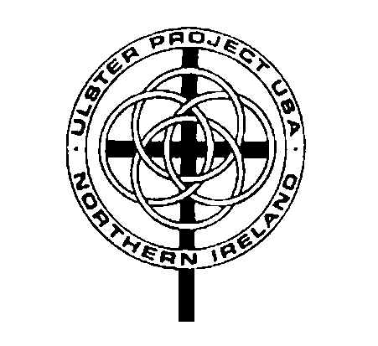

Meeting Agenda

Alliance Area Ulster Project

Date: October 1, 2018

Opening Prayer/Scripture: John 17:23 I in them and you in me—so that they may be brought to complete unity. Then the world will know that you sent me and have loved them even as you have loved me.

Attendance sheet- please sign in
- Treasurer’s report-
- Correspondence –
- Old business-
- New Officers
- Youth Protection Training on line by Oct. 1
- Donations of Support for Jacci Adams, Erin Rogers
- Other:

- New Business-
- International conference: August 17-20, 2019 in Milwaukee. The date has been moved to the summer to take advantage of the Irish Fest in Milwaukee and for UP Milwaukee to celebrate 40 years. Our Expense-$200
- Auction Update:
- Confirmed with Father Forsythe 8 teens and 2 counselors, shared evaluation results
- Other: “The Priests” Palace Theater Sat. Nov. 17 7:30 PM $30 Father David Delaney former Ulster teen!
Group of 10 or more and we get $5 discount

Adjournment-Next meeting November 5, 2018

